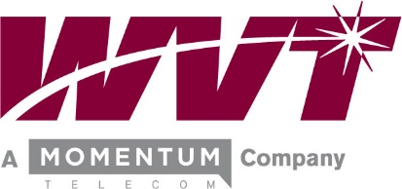

Tariffs and Regulations

Alteva of Warwick, LLC; d/b/a Warwick Valley Telephone provides service in New York and New Jersey and is subject to regulations from both the New York State Department of Public Service and the New Jersey Board of Public Utilities. Tariffs showing rates, rules and regulations for service are available for public inspection at our Business Office at 47 Main St, Warwick, NY, and also at the commissioner’s office at Office of Consumer Services, NYS Department of Public Service, 2 Empire Plaza, Albany, NY for the New York Tariff and at the New Jersey Board of Public Utilities Office, Division of Customer Assistance, 44 South Clinton Ave., 1st floor, Trenton, NJ; for the New Jersey Tariff.

